Advanced SQL Exercises for Online Retail Store
Exercise 1: Ranking and Window Functions
Goal: Use ROW_NUMBER(), RANK(), DENSE_RANK(), OVER(), and PARTITION BY.
Scenario:
Find the top 3 most expensive products in each category using different ranking functions.
Steps:
1. Use ROW_NUMBER() to assign a unique rank within each category.
2. Use RANK() and DENSE_RANK() to compare how ties are handled.
3. Use PARTITION BY Category and ORDER BY Price DESC.

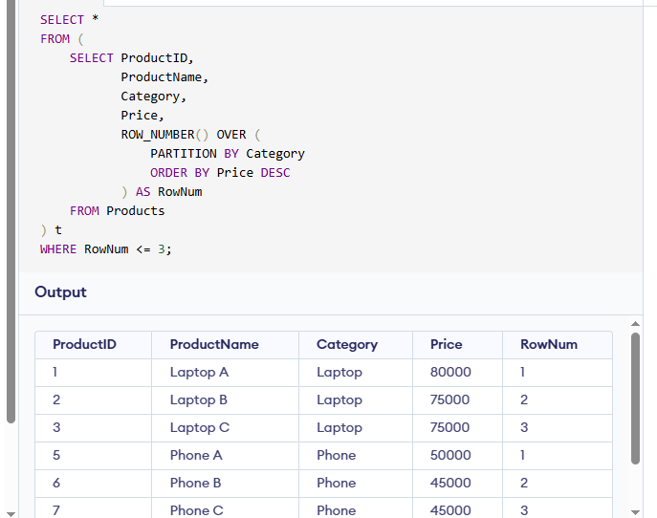

Exercise 2: Aggregation with GROUPING SETS, CUBE, and ROLLUP
Goal: Analyze sales data across multiple dimensions.
Scenario:
Generate a report showing total quantity sold by Region and Category using GROUPING SETS, ROLLUP, anSteps:
1. Join Orders, OrderDetails, Customers, and Products.
2. Use GROUPING SETS to get totals by Region, Category, and both.
3. Use ROLLUP to get subtotals and grand totals.
4. Use CUBE to get all combinations of Region and Category

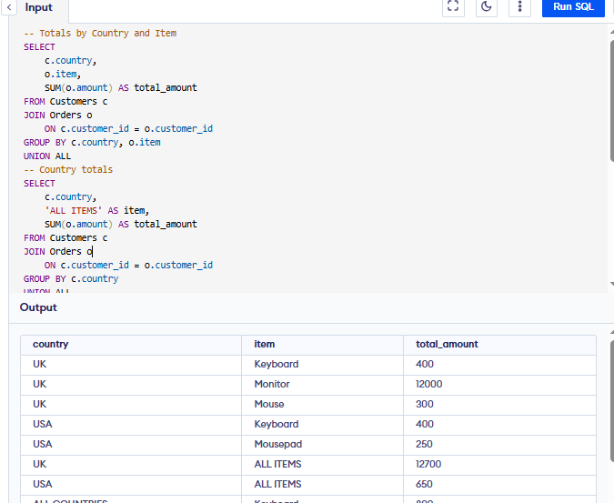
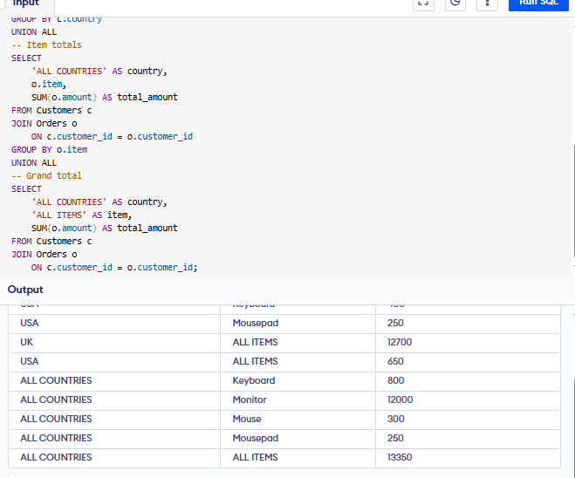

Exercise 3: CTEs and MERGE
Goal: Use WITH, CTEs, Recursive CTEs, and MERGE.
Scenario:
a) Create a recursive CTE to generate a calendar table.
b) Use a MERGE statement to update or insert product prices from a staging table.
Steps:
1. Create a recursive CTE to generate dates from '2025-01-01' to '2025-01-31'.
2. Create a StagingProducts table with updated prices.
3. Use MERGE to update existing products or insert new ones.
